**Chapter 2**

**Limits**

**2.3 The Limit Laws**

**Section Exercises**

**In the following exercises, use the limit laws to evaluate each limit. Justify each step by indicating the appropriate limit law(s).**

83. 

Answer: Use constant multiple law and difference law: 

85. 

Answer: Use root law: 

**In the following exercises, use direct substitution to evaluate each limit.**

87. 

Answer: 49

89. 

Answer: 1

91. 

Answer: 

**In the following exercises, use direct substitution to show that each limit leads to the indeterminate form  Then, evaluate the limit.**

93. 

Answer: ; then, 

95. 

Answer: ; then, 

97. 

Answer: ; then, 

99. 

Answer: ; then, 

101. 

Answer: ; then, 

**In the following exercises, use direct substitution to obtain an undefined expression. Then, use the method of Example_02_03_11 to simplify the function to help determine the limit.**

103. 

Answer: –∞

105. 

Answer: –∞

**In the following exercises, assume that , , and . Use these three facts and the limit laws to evaluate each limit.**

107. 

Answer: 

109. 

Answer: 

111. 

Answer: 

113. 

Answer: 

**[T] In the following exercises, use a calculator to draw the graph of each piecewise-defined function and study the graph to evaluate the given limits.**

115. 

1. 
2. 

Answer:

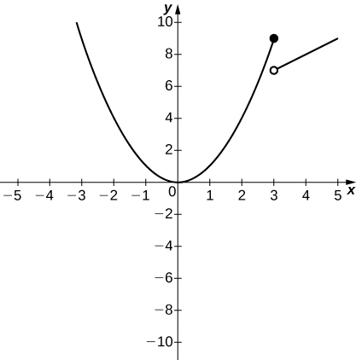

a. 9; b. 7

117. 

1. 
2. 

Answer:

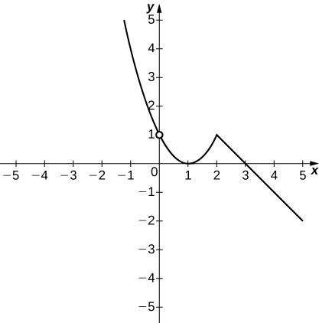

a. 1; b. 1

**In the following exercises, use the following graphs and the limit laws to evaluate each limit.**

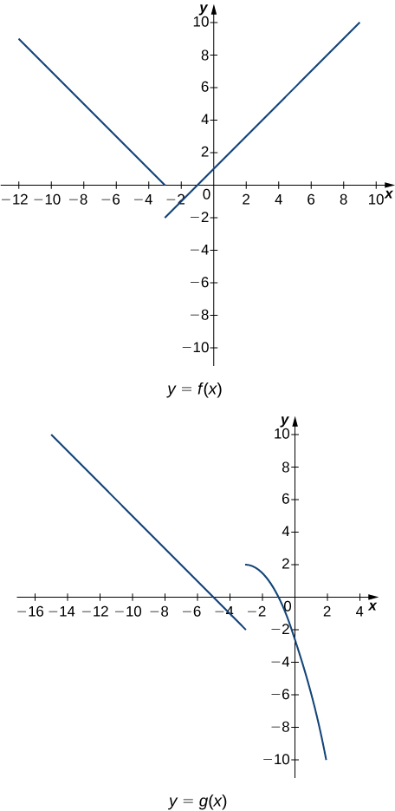

119. 

Answer: 

121. 

Answer: 

123. 

Answer: 

125. 

Answer: 

**For the following problems, evaluate the limit using the squeeze theorem. Use a calculator to graph the functions ,, and  when possible.**

127. **[T]** 

Answer: The limit is zero.

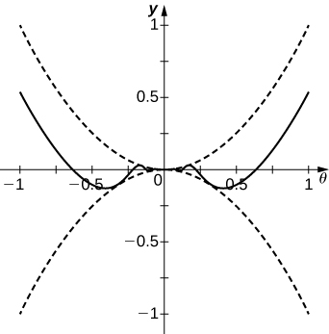

129. **[T]** In physics, the magnitude of an electric field generated by a point charge at a distance *r* in vacuum is governed by Coulomb’s law:  where *E* represents the magnitude of the electric field, *q* is the charge of the particle, *r* is the distance between the particle and where the strength of the field is measured, and  is Coulomb’s constant: 

1. Use a graphing calculator to graph  given that the charge of the particle is .
2. Evaluate . What is the physical meaning of this quantity? Is it physically relevant? Why are you evaluating from the right?

Answer: a.

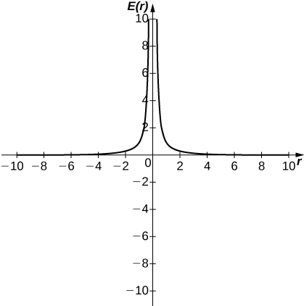

b. ∞. The magnitude of the electric field as you approach the particle *q* becomes infinite. It does not make physical sense to evaluate negative distance.

**Student Project**

**Deriving the Formula for the Area of a Circle**

1. Express the height *h* and the base *b* of the isosceles triangle in the figure below in terms of  and *r*.

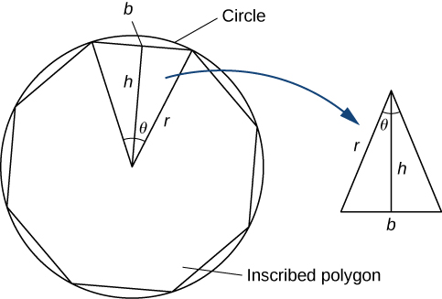

Answer: 1. and

3. If an *n*-sided regular polygon is inscribed in a circle of radius *r*, find a relationship between *θ* and *n*. Solve this for *n*. Keep in mind there are 2*π* radians in a circle. (Use radians, not degrees.)

Answer:

5. To find a formula for the area of the circle, find the limit of the expression in step 4 as *θ* goes to zero. (*Hint:* ).

Answer: Area of circle $\lim_{θ→0}{\frac{πr^{2}\sin{θ}}{θ}=πr^{2}}$

This file is copyright 2016, Rice University. All Rights Reserved.